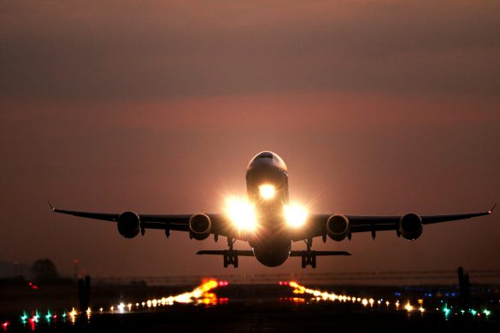

Živković Samardžić advises Belgrade Nikola Tesla Airport on third consecutive capital increase

Živković Samardžić, one of the Serbia’s leading full-service independent law firms, has advised Belgrade Nikola Tesla Airport (NTA), a joint-stock public company that owns and operates the largest and busiest airport in Serbia – the Belgrade airport, on its third consecutive issuance of shares and share capital increase in less than five months.
The company increased its share capital through contribution of approximately EUR 2,000,000 worth 20 real estate properties required for further development of NTA and owned by NTA’s majority shareholder – Republic of Serbia.
As the share capital increase was performed as an in-kind contribution by the Republic of Serbia — one of more than four million NTA shareholders — only the Republic of Serbia was remunerated by the issuance of new shares, while the preferential subscription rights of the remaining shareholders were excluded.
The issuance of shares and share capital increase was performed as part of preparatory actions for the concession granted to the French airport operator Vinci Airports for the financing, development through construction and reconstruction, maintenance, and management of infrastructure of the NTA.

