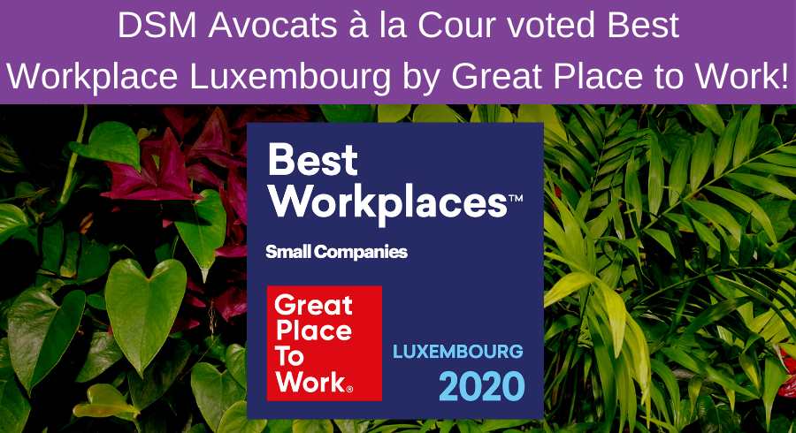

DSM Avocats à la Cour voted Best Workplace Luxembourg by Great Place to Work!

Each year the Great Place to Work® Institute rewards organizations where it is good to work in over 60 countries. In 2020, the Institute celebrates its 10th edition in the Grand Duchy of Luxembourg for the occasion it rewards 20 enterprises that make confidence a vehicle for performance and well-being in the workplace. This year is DSM Avocats à la Cour’s first time in participating in the category of Small Companies, which represents organizations of 20 to 49 persons.

We are thus delighted to announce that DSM Avocats à la Cour is one of the ʺBest Workplacesʺ in Luxembourg*.
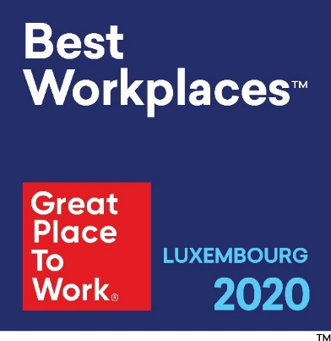
As a signatory to the Diversity Charter and member of Inspiring More Sustainability Luxembourg, DSM Avocats à la Cour sees its practices and values being rewarded.
For the occasion, Mario DI STEFANO, DSM Avocats à la Cour’s Managing Partner responded to a few questions from Great Place to Work Luxembourg:
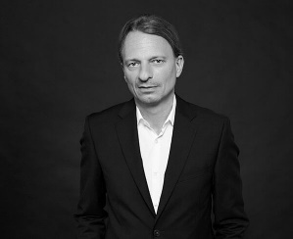
Great Place to Work: According to the people who work at DSM, what is the reason for which DSM is a good firm at which to work?
Mario DI STEFANO: DSM Avocats à la Cour has a stable and pleasant environment where it is good to work. We are aware of the value of the people who work here and seek to find ways for them to develop and find their place at DSM by valuing, empowering, respecting them, always considering the human side as the center of our way of doing things.

Great Place to Work: The advantage that the Best Workplaces® label brings/will bring to your firm?
Mario DI STEFANO: The Best Workplaces label rewards and materializes our efforts at workplace well-being. Thus, it increases DSM’s attractiveness to talented individuals seeking a career that suits them. Above all, we understand that being a Best Workplace is a continued and daily effort. Thus, thanks to Great Place to Work’s audit, we have been able to evaluate ourselves and identify points requiring improvement to further improve our workplace.

Great Place to Work: Your firm’s force?
Mario DI STEFANO: Excellence, reactivity and pragmatism.

Great Place to Work: The best internal tool/means of communication?
Mario DI STEFANO: Yesterday, coffee breaks. Today, videoconferences. Tomorrow, a little bit of both.

Great Place to Work: Your HR priority for 2020?
Mario DI STEFANO: Meet the challenges of the public health crisis, protect the health and safety of all who work at DSM and our clients, through telecommuting and holding meetings by videoconference, while taking into account the results of the Great Place to Work survey. It is by offering the best possible environment to all who work here that we will continue each day to bring excellent service to our clients.

*According to DSM personnel and the criteria defined by Great Place to Work Luxembourg.

